Footprint Counting using Face Recognition
Yogita Dubey  Department of Electronics and  Telecommunication  Yeshwantrao Chavan College of  Engineering  Nagpur, India  yogeetakdubey@yahoo.co.in  Samruddhi Uplapwar  Department of Electronics and  Telecommunication  Yeshwantrao Chavan College of  Engineering  Nagpur, India  samruddhiuplapwar18@gamail.com | Yashaswi Rewatkar  Department of Electronics and  Telecommunication  Yeshwantrao Chavan College of  Engineering  Nagpur, India  rewatkaryashaswi27@gmail.com  Nikita Parate  Department of Electronics and  Telecommunication  Yeshwantrao Chavan College of  Engineering  Nagpur, India nikitaparate2002@gmail.com | Saloni Giratkar  Department of Electronics and  Telecommunication  Yeshwantrao Chavan College of  Engineering  Nagpur India  giratkarsaloni1@gmail.com  Neelam Mulmuley  Department of Marketing and Customer  Relation  Ajmera Tyres Pvt. Ltd  Nagpur, India sales@ajmeratyres.com

Abstract— Face detection is one of the most advanced technologies in the current era. Based on face feature detection and recognition, this research provided a system for counting individuals. The live feed is recorded in video format. Face detection, face recognition, feature extraction, and counting are the four parts of this system. The viola Jones approach for facial recognition was used to recognise faces in images. This approach is quicker than others and produces more accurate results when the facial traits of a person are examined using the Adaboost algorithm. It was used to distinguish between the face and non-facial areas. If a face is recognised, it is known. If it is unknown, this individual will be counted. The results of the experiments reveal that the system successfully counts people with great efficiency and accuracy.
Keywords— Footprint Count, Face detection, Face
Matching, and Face Classification.

I. INTRODUCTION
The face recognition mechanism is a signature mechanism that is primarily focused on the recognition of a person's facial traits. Following the collection of facial photographs, the recognition tools process the photos automatically. The presentation discusses relevant studies on face recognition from several perspectives. In general, the facial recognition process consists of three stages: detection, recognition, and extraction. Face detection is the technique of detecting face characteristics in an image or video.
XXX-X-XXXX-XXXX-X/XX/$XX.00 ©20XX IEEE
Face identification in video track has long been a demanding area, requiring a series of studies to designate a specific face in the video track. After recognizing the region, several unique traits are retrieved to distinguish one face from another. [1] There are three main approaches for detecting the face using the Viola-Jones algorithm. An integral picture is utilised to extract the properties of Haarlike features. Adaboost machine learning algorithms are employed to recognise faces. This is mostly used to improve categorization at each level [2]. Following a thorough classification process, a Cascade classifier is used to the selected area in order to capture a face or non-facial model [3].
LU Wen-Yao conducted research and enhanced the performance of the Viola-Jones method employing
Composite characteristics to minimise the error estimation of face detection [4]. An artificial neural network and the main Component Analysis algorithm are utilised to identify and recognise the face in order to provide accurate results. The image processing-based approach were proposed [5,6].
To achieve real-time crowd counting, Bale and Monalisa [7] catch the moving object by positioning the camera perpendicular to the top of the specified entrance across the selected portion of the image sequence. In the business, we may count the number of people who come in and give the information to the owner. Face Recognition and Counting using Raspberry Pi based on IOT was proposed. It avoids duplicate persons by recognising faces and counts the number of people in certain regions.
This paper is implementation of a system for footprint counting using face recognition which is developed for Ajmera Tyre, Nagpur. The proposed system can be used by any industry for footprint count of their visiting customers and track a record of that. The paper is organized as follows. The proposed system is described in section II, results and analysis in section III followed by conclusion in section IV.
II. PROPOSED SYSTEM
The proposed system for footprint count is shown in Fig. 1. Using the Viola Jones algorithm, the proposed method implements an efficient face detection methodology that is independent of the quantity of in characteristics such as color, hairdo, tone, brows, and distinct face expressions. The steps involved are described below
Step 1: The camera module captures live images.
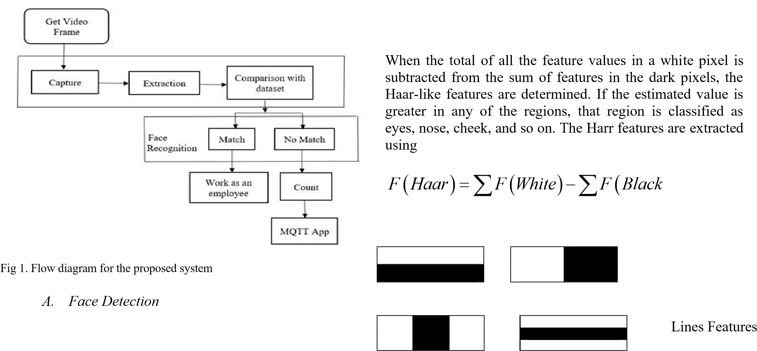
Step 2 The camera constantly examines the video frame and outputs a picture if a human face is detected.
Step 2: The captured image is then compared to the system's Known Dataset.
Step 3: If the person's face does not match any of the entries in the dataset, the name provided will be automatically labelled as "Unknown" and a notice with the word "Unknown" will be sent to the Android application (MQTT APP). In response to a message, the app will count the "unknown" number. 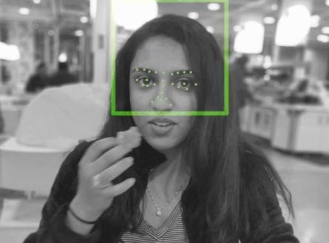
Face detection techniques are divided into two types: feature-based approaches and image-based approaches. For feature analysis, the feature-based technique is applied. The image-based method recognizes face objects. It's the first step toward automatic facial recognition. First, the input picture is transformed to grayscale, and then its placement on the colored image is determined. Using contrast stretching, white pixels are made whiter and black pixels are made darker at the pre-processing step.

Fig 2. Location of image feature

B. Viola-Jones Algorithm
The Viola-Jones Algorithm is used after pre-processing to detect a face in a picture. The Viola-Jones approach was chosen because it is quicker than other methods, has a high detection rate with a high true-positive rate and a low falsepositive rate, and always runs in real time. The Viola-Jones approach is effective on frontal facial photographs, and it rotates the image by 45 degrees in both the vertical and horizontal axes.

C. Haar-Like Characteristic
Haar-like features are virtual picture characteristics that are employed in real-time face detection algorithms. The Haarlike characteristics are four-sided rectangular frames that may be used to compare white pixels to grey pixels. In Fig. 3, three types of Haar features are shown: edge features, line features, and four-rectangle features. Edge and Line characteristics are important for determining picture edges and lines. Four-sided characteristics are used to detect diagonal features.

F Black) (1)

Edge Features

Four Rectangle Features

Important Features for Face Detection

Fig 3. Features of Faces Detection
For example, consider a block of image and vertical edge feature as shown
5 | 3
4 | 2

Then Haar feature is computed as
(1 5 1 4 +  −  +  = − =) (1 3 1 2) 9 5 4

Fig 4. Face features identified

D. Integral Image
An Integral Image is a transitional representation of an image in which the value per pixel equals the sum of the top and left pixels. The integral image representation is required because it allows for quick calculation of rectangular regions. Integral image is formed using
M N

g x y( , ) = f x y( , ) (2) x= =1 y 1
Where, g x y( , ) is the integral image and f x y( , ) is the original image of size M N . The formation of integral image can be explained in following way. Consider 4 bit original images f x y( , )
⬆ 1  ⬇ 9 f x y( , ) =⬇  ⬇12 | 8  15  1 | 5  7  5 | 6  11   6 
⬇ 
12 2 8 9 ✗
The integral image g x y( , ) obtained using Equation 2
would be
⬆ 1  ⬇10 g x y( , ) =⬇  ⬇22  ⬇  34 | 9 33  46  60 | 14 45  63  85 | 20   62     86   117✗

E. Adaptive boosting Algorithm
Adaboost method merges several "weak classifiers" into a single "strong classifier" as shown in Fig. 5. It evaluates the performance of each classifier and is used to reduce calculation complexity. [2]. It is a face detection machinelearning method. The primary goal of face detection is to identify the facial and non-facial areas. Adaboost assigns a weight to each of them after identification.
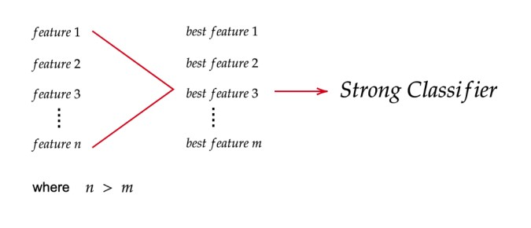
Fig. 5 Extraction of best feature using Adaboost Algorithm

F. Cascade Classifier
The cascade classifier removes non-faces while producing accurate results as shown in Fig. 6. The cascade system divides face identification into numerous steps for the categorization of the best feature. If all of the image's characteristics are accepted, it is finally designated as a human face.
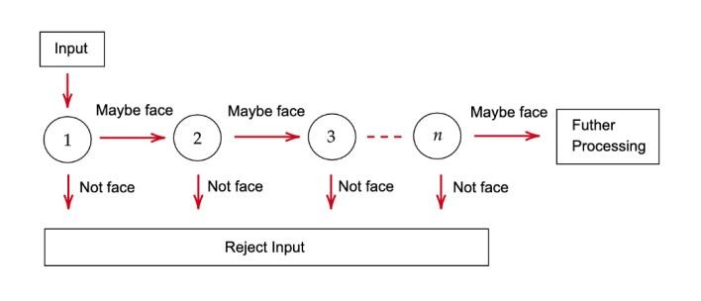
Fig. 6 Cascade Classifier
III. RESULTS AND DISCUSSION
The suggested system performs facial recognition and face detection by matching the image with a predefined database. If the individual's face does not match the dataset, the person is assumed to be unknown. And the data is seen on the internet platform app provided by the MQTT app. If the Persons face does not match with the values listed in dataset then the system will thereby determine the recognized face as "unknown" and send a message containing "unknown" to the Android application (MQTT APP). The app will respond to a message and count that "unknown" value. Fig. 7 and 8 depict the recognition of known and unknown faces.
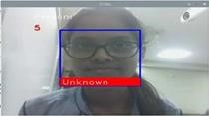
Fig 7. The System Recognizing Unknown Face Correctly
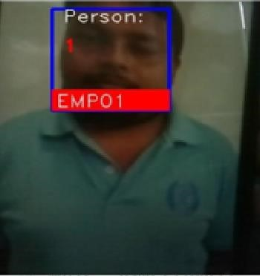
Fig 8. The System Recognizing Known Face Correctly
The values of Footprint count will be displayed as shown in the
Fig. 9


Fig 9. Footprint Count
The prototype of proposed system for footprint counting using face recognition is shown in Fig.10.
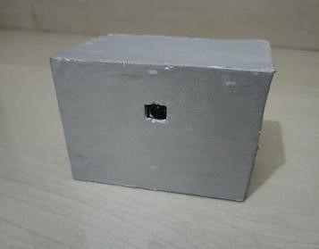
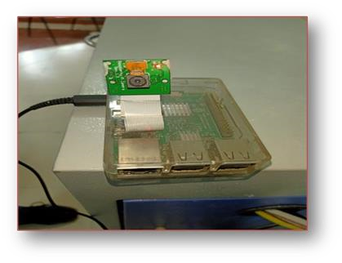
Fig 8. The setup for Foot print count using Face Recognition

The system used Raspberry Pi module. Accuracy of the system is calculated using
Countof Unknown Person
Accuracy =

Total Numberof UnknownPersonintheVideo
The accuracy of the system calculated for three videos taken from the employees of the Ajmera Tyre Pvt. Ltd, Nagpur is shown in TABLE I.
TABLE I. ACCURACY OF THE PROPOSED SYSTEM FOR FOOT
PRINT COUNTING
Video | Unknown person in video | Unknown  person count | Accuracy (in %)
Video 1 | 10 | 9 | 90
Video 2 | 6 | 6 | 100
Video 3 | 7 | 6 | 85.71
IV. CONCLUSION
Face detection and identification are critical in a variety of applications. Today, identification information may be checked automatically for secure transactions, tracking, security, and building access control. A high degree of accuracy in identifying a person is sought in the majority of applications. The Viola-Jones algorithm is used in this research to offer an efficient solution for face detection and identification. The goal of this paper is to recognize faces and keep track of the number of visitors in the shopping centre using Raspberry Pi with high accuracy results. Gender identity is undoubtedly one for the future. The suggested technology can be employed in a variety of settings.
REFERENCES
- A. F. Ab. Nasir, A. S. Abdul Ghani, M. A. Zakaria, A. PP Abdul Majeed, and A. N. Ibrahim, “Automated Face Detection Using Skin Color Segmentation and Viola-Jones Algorithm”, MEKATRONIKA, vol. 1, no. 1, pp. 58–63, Jan. 2019
- V. K and S. Padmavathi, “Facial Parts Detection Using Viola,” Intertational Conference on Advanced . Adv. Computing and Communication System, (ICACCS -2015), pp. 1–4, 2017.
- A. Gupta and R. Tiwari, “Face Detection Using Modified Viola Jones Algorithm,” International Journal of Recent Research in Mathematics Computer Science and Information Technology., vol. 1, no. 2, pp. 59– 66, 2015.
- Lu, Wen-yao and Ming Yang. “Face Detection Based on Viola-Jones Algorithm Applying Composite Features.” 2019 International
Conference on Robots & Intelligent System (ICRIS), pp. 82-85, 2019
- A. Albiol, I. Mora and V. Naranjo, "Real-time high density people counter using morphological tools," in IEEE Transactions on Intelligent Transportation Systems, vol. 2, no. 4, pp. 204-218, Dec. 2001, doi: 10.1109/6979.969366.
- T. H. Chen, T. Y. Chen and Z. X. Chen, "An Intelligent People-Flow
Counting Method for Passing Through a Gate", 2006 IEEE International Conference on Cybernetics Intelligent Systems (CIS), Bangkok, Thailand, pp.573-578, June 2006.
- Holkunde Monalisa,and Veerbhadra Bale,”Face Recognition and
Counting using Raspberry Pi with IOT”,Vol 11, No. 1, Jan 2020

